SELF ASSESSMENT EVIDENCE
TRANSPORT LAYER
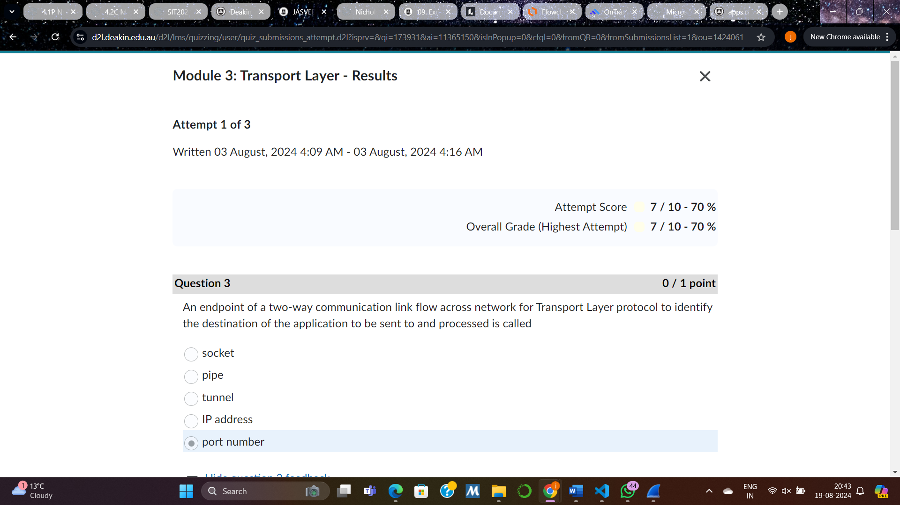
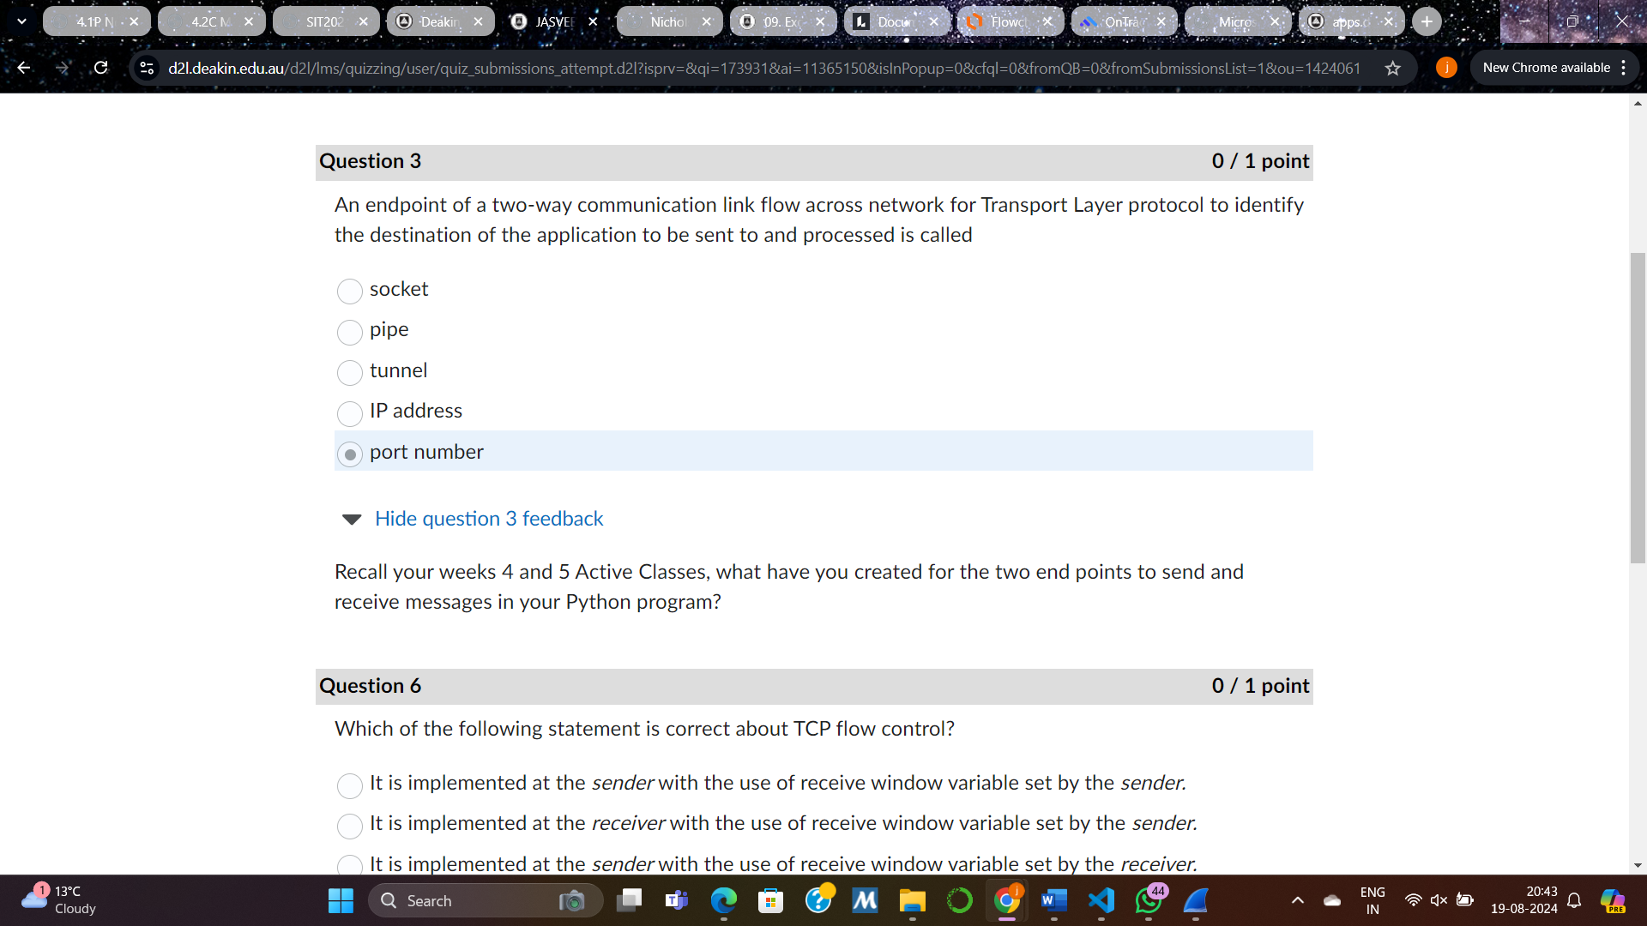
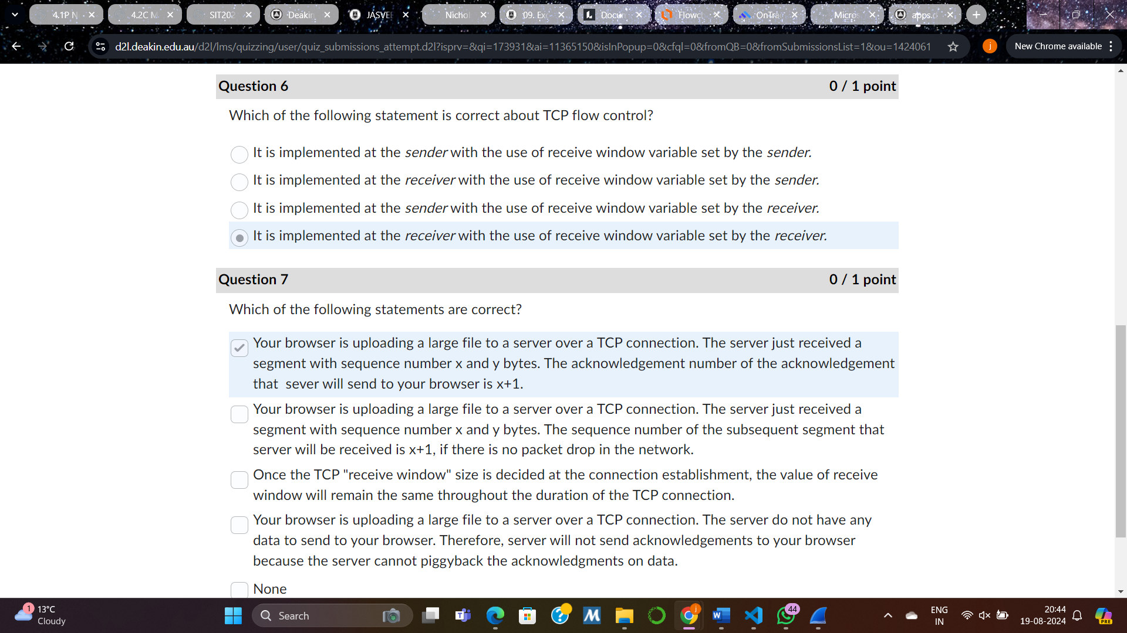

QUESTION3 : An endpoint of a two-way communication link flow across network for Transport Layer protocol to identify the destination of the application to be sent to and processed is called
Correct Answer:
Socket
Explanation:
- Socket: In the context of network communication, a socket is used to define the endpoint for sending and receiving data. It combines the IP address (which identifies a device on the network) and a port number (which identifies a specific application or service on that device). This combination allows for communication between applications across a network.
The other options do not fit the specific role of identifying an endpoint in network communication:
- Pipe: Generally used for inter-process communication within the same machine.
- Tunnel: Refers to a method for encapsulating one protocol within another, often used for secure communication over a network.
- IP Address: Identifies a device on the network but does not specify the application or service on that device.
- Port Number: Identifies a specific application or service but does not uniquely define the endpoint without the IP address.

QUESTION 6: Which of the following statement is correct about TCP flow control?
ANSWER: It is implemented at the sender with the use of receive window variable set by the receiver.
Explanation:
TCP flow control is designed to prevent the sender from overwhelming the receiver with too much data too quickly. Here’s how it works:
- Receive Window Variable: This variable is set by the receiver and indicates the amount of buffer space available for incoming data. It is communicated to the sender through the TCP header.
- Sender's Role: The sender uses the receive window size provided by the receiver to determine how much data it can send before needing an acknowledgment. This ensures that the sender does not send more data than the receiver can handle, preventing buffer overflow.
QUESTION 7: Which of the following statements are correct?
Question options:
Your browser is uploading a large file to a server over a TCP connection. The server just received a segment with sequence number x and y bytes. The acknowledgement number of the acknowledgement that sever will send to your browser is x+1.
Your browser is uploading a large file to a server over a TCP connection. The server just received a segment with sequence number x and y bytes. The sequence number of the subsequent segment that server will be received is x+1, if there is no packet drop in the network.
Once the TCP "receive window" size is decided at the connection establishment, the value of receive window will remain the same throughout the duration of the TCP connection.
Your browser is uploading a large file to a server over a TCP connection. The server do not have any data to send to your browser. Therefore, server will not send acknowledgements to your browser because the server cannot piggyback the acknowledgments on data.
None
ANSWER:
- Your browser is uploading a large file to a server over a TCP connection. The server just received a segment with sequence number x and y bytes. The acknowledgment number of the acknowledgment that server will send to your browser is x+1."
  - Incorrect. The acknowledgment number sent by the server will be x + y. This indicates that the server has received all bytes up to x + y - 1 and is expecting the next byte to be x + y.
- "Your browser is uploading a large file to a server over a TCP connection. The server just received a segment with sequence number x and y bytes. The sequence number of the subsequent segment that server will be received is x+1, if there is no packet drop in the network."
  - Incorrect. The sequence number of the subsequent segment that the server will receive would be x + y, not x + 1. The x + 1 would be the sequence number of the next segment sent by the browser if the current segment ends at x + y - 1.
- "Once the TCP 'receive window' size is decided at the connection establishment, the value of receive window will remain the same throughout the duration of the TCP connection."
  - Incorrect. The receive window size is not fixed and can change during the connection. It can be adjusted dynamically based on the receiver's buffer availability.
- "Your browser is uploading a large file to a server over a TCP connection. The server does not have any data to send to your browser. Therefore, the server will not send acknowledgments to your browser because the server cannot piggyback the acknowledgments on data."
  - Incorrect. The server will still send acknowledgments even if it does not have data to send. TCP acknowledgments can be sent independently of data transmission.
Correct ANSWER:
- None of the statements are correct.

